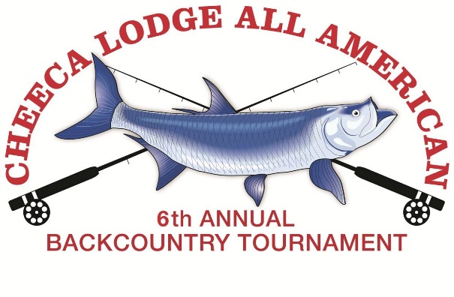
SCHEDULE OF EVENTS

Thursday, November 16, 2017
5:00 – 8:00pm Welcome Reception and Dinner at Cheeca Lodge
6:00pm Rules Meeting (Guides must attend)

Friday, November 17, 2017
6:00 – 6:30am Continental Breakfast (at World Wide Sportsman)
6:30am Boats may depart
7:00am Lines in
3:00pm Lines out
3:00 – 5:00pm Submit Results to Scorekeeper (World Wide Sportsman)
Saturday, November 18, 2017
6:00 – 6:30am Continental Breakfast (at World Wide Sportsman)
6:30am Boats may depart
7:00am Lines in
3:00pm Lines in
3:00 – 4:00pm Submit Results to Scorekeeper (World Wide Sportsman)
5:30 pm Cocktail Reception, Dinner, Auction and Awards
Proceeds benefit Guides Trust Foundation

For more information or additional entry forms, please visit www.cheeca.com/all-american or contact Lisa Thornhill at (305) 517-4512 or e-mail lthornhill@cheeca.com

